Homework #9
Jay Franck
ASTR 610 Fall 2010

1.

i. Running ELC with the orbital elements found in Homework #7, as well as the mass function (0.0418) and the parameter changes listed in the assignment, I was able to synthetically create a single-lined binary. I plotted the folded radial velocity versus phase from a previous assignment and the synthetic binary in XMGRACE. The first figure appended to this paper clearly shows the synthetic curve going through the points of the graph.

ii. Examining the ELC.out file lists the mass of the first star as 0.166 solar masses and an effective temperature of ~5000.0 K, which is an early G-type star of roughly 1 solar mass.

Changing the binary system to an inclination of 80º results in a mass of 0.174 solar masses, and an effective temperature of 5000.0 K. The curve still goes through each of the points on the graph.

In order to get the mass of the first star to be ~1.027 solar masses, the inclination must be changed to i=33.0º. Plotting the radial velocity observations on the synthetic curve as a function of phase still results in the curve passing through each point.

iii. Changing the mass ratio Q = 5 and the inclination to 90º, the resulting ELC generated radial velocity curve still was able to fit the observed points very nicely with still no noticeable change from part (i). The mass of the first star is listed as 0.012 M solar, with a companion of 0.06 M solar. Obviously, this is not a reasonable answer.

In order to get a reasonable answer for the mass of the first star, the finc ~ 13.00º in order to get a mass of about 1.049 M solar.

iv. Obviously a single velocity curve is not an effective method of determining the absolute masses of a system. In every case the observed velocities would fit the synthetic velocity curve, but these had an extremely wide range of free parameters that had to be adjusted in order to get the 'correct' answer for the given spectral type. It is apparent that much more data would be needed in order to determine the absolute masses.

2. For the optimization of 1 Spu, I chose to run the amoeba. From the previous assignments, the majority of orbital elements for 1Spu were known to reasonable precision. However, for the first input file, relatively loose values were chosen to ensure that the aforementioned 'precision' was reasonable. As the manual suggested, the number of restarts for the amoeba was chosen to be 2, and the step sizes were larger than those of the loop intervals used in the previous assignment.

The final result from the first amoeba trial was outputted as follows:

33.8350000 1.0000000 pk
45785.6650000 2.0000000 t0
0.0080000 0.0100000 ecc
0.0220000 0.0100000 arg
10.3365000 0.0250000 period
The values in the 1st column are the optimized parameters of the 3rd column. The 2nd column represents the step sizes chosen for this computation. The χ² value associated with the parameters was
S =29.245967, a difference of ~28.489 from the value found in HW7, so obviously a better fit was achieved.

A second execution of the amoeba was run with ambitiously smaller step sizes (on the order of the intervals used in the loop algorithm of HW7), in the hope that this would achieve a more accurate fit.
The input file for this run is appended to this paper as 'gridloop.opt' for the convenience of the reader.
The result was:

33.7501607 0.1000000 pk
45785.6445403 0.0100000 t0
0.0050088 0.0100000 ecc
0.0159365 0.0100000 arg
10.3367397 0.0050000 period
S = 27.119374

This result was achieved after a significantly longer computing time, and was stored as the 'correct' or final values of the five parameters. The values of the parameters found in the previous homework is as follows:

HW7 Paramaters | Value | Error
Period (P) | 10.3365 days | ±0.0002 days
Time of Periastron (T₀) | 45785.665 | ±0.005
Semi-amplitude of the Velocity (K) | 33.835 km/s | ±0.175
Systemic Velocity (γ) | 33.40 km/s | ±0.15
Argument of Periastron (ω) | 0.002º | ±0.002º
Eccentricity (e) | 0.008 | ±.003
χ² value | 57.7347

It is apparent that although the amoeba changed a few of the values, the changes from HW7 are not incredibly large and agree with the derived values within the specified errors.

I believe the main reason for the differences lie in the inefficiency, as well as the large interval sizes, of the HW7 loops. By increasing the manual interval changes over a larger number of iterations from HW7, the values found by the amoeba could be achieved. However, I do believe that the number of iterations used in the ELC amoeba were sufficient to produce a reasonable value for each parameter.

The results were not incredibly sensitive to my initial guesses, as both executions of the amoeba contained initial values close to the correct values. However, using less precise guesses (for instance, the initial approximations used in the beginning of HW7), yielded less ideal results. Refer to Table 1 for the values of the initial parameters and final values produced. I conclude that the results are very sensitive without a reasonable idea of the initial values to produce a precise model.

Initial Input Values from HW7.1 | Step Sizes | Resulting Amoeba Values
K = 35 | 0.1 | 34.9879
T₀ =45785.66 | 0.1 | 45785.6918
ecc = 0.12000 | 0.1 | 0.04299
ω =0.000 | 0.1 | 0.1761
Period =10.338 | 0.05 | 10.3360
Table 1: Using the input values from the first (unoptimized) parameters from the beginning of HW7, and the following stepsizes with the amoeba in ELC, the resulting model was produced with a χ² value of 57.081. It is obvious that without reasonable initial guesses, a less viable model is constructed.

3.

i. Using all of the values from (2) and inputting them into ELC.inp.example (except for the eccentricity, which was set to e=0.30), I computed the light curves for each of the step sizes of ω. Plotting each of the light curves in XMGRACE, I would move the cursor on the plot to find the values of the primary and secondary eclipse, as well as the width of each eclipse. The value of the magnitude and phase are listed for the exact position of the mouse in the upper left hand corner of plotting window, which increased the precision of the measurements drastically compared to simply measuring off the axes. A plot of the V-band light curve for ω = 0º generated in this manner is appended to this paper for the readers convenience ('Figure 2'). See Table 2 for the list of measured and calculated values.
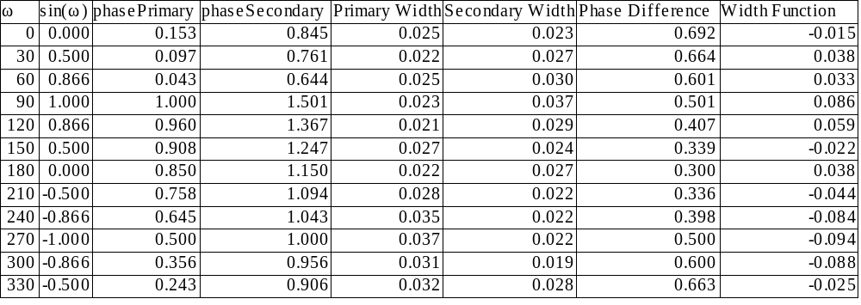

Table 2: Using the method described in (3i) to find the values of the primary and secondary eclipses, as well as measuring the width of each, the phase difference was calculated as well as sin( ω) and the width function used in (3iv) for each ω interval.

ii. Using the values in Table 2 and plotting them using XMGRACE, a parabolic function was evident for the Phase Difference vs. ω diagram, as shown in Figure 3 (appended to this paper). At ω =180º, the separation between the phases is the smallest, while at 0º(and 360º), the phase seperation is the greatest.

iii. The derivation of this function is appended to the end of this paper for the reader's convenience on notebook paper.

Using the analytic equation, a Python program was constructed in order to generate a text file with the synthetic Phase Difference vs. ω data, which was then plotted with XMGRACE. The resulting Figure 4 is appended to this document, illustrating the fact that the analytic expression is consistent with the computed values for the phase difference, with only a slight variation at ω=180º.

The program and data file are appended for the readers convenience.

iv. Using the calculated values in the 'Width Function' column, a plot was created in XMGRACE that illustrates the relationship between sin( ω) and the Width Function. There is a definite linear relationship, as sin(ω) increases, the value of the width function also increases.

v. The use of the graph for part ii (or the equation from part iii) is readily apparent. If you know the phase difference between the primary and secondary eclipses, and the difference between these is a function of ω, you basically can find omega in short order, which is a key component in determining other parameters when modeling binaries.

The graph in part iv is also important, as the measure of the relative widths of the eclipses reveals the ω as well. Given a value for the width of the eclipses, it would then be a trivial matter to approximate the value for ω.

4. It is possible to create a single lined binary system for two somewhat 'normal stars'. The most important factors when creating a single lined binary system is the changing ω, the inclination, and the eccentricity, and the mass ratio Q. 'Normal' in this case is a little relative, as the eccentricity is extremely large in this particular case, but the mass ratios and everything else are quite reasonable.

The values changed from the provided ELC.inp.example file are Q =1.0, eccentricity = 0.85, the inclination i = 80º, and ω=90º.

The visual-band light curve is appended to this paper as "Problem 4" for reference.

5. The derivation is appended on notebook paper to the end of this report.

6. The derivation and subsequent calculations is appended on notebook paper to the end of this report.

References

Franck, Jay. Homeworks 4,6,7. Astronomy 610, Fall 2010. San Diego State University

Hilditch, R.W. An Introduction to Close Binary Stars. Cambridge University Press; 1 edition. Mar 2001

Orosz, J. Astronomy 610 Lecture Series, Fall 2010. San Diego State University

